**Enterprise Resource Planning**

**Training User Manual**

**VERSION 12.0.0**

**Administration**

# Administration

**Options**

1. Master Setup
2. System Administration
3. Advance Option
4. Admin AP/AR
5. Error Handling
6. SQLDB Backup (Admin)

# Master Setup

# GL Codes & Parameter

# AR Codes & Parameter

# AP Codes & Parameter

# PO Codes & Parameter

# Sales Codes & Parameter

# IM Codes & Parameter

# Units of Measurements

# Party Master

# Item Master

# Store Master

# Branch Master

# Serial Code

# Non-Serial Code

# Bank

# Year

* **Entry of Codes & Parameter**

# Codes & Parameter

|  |  |  |
| --- | --- | --- |
| **Step 1** |  | Open System **>** Administration> Master Setup **>** Codes & Parameter (Open any screen to entry Code) |
| **Step 2** |  | Write Transaction code name & check the Activate box. Write number , Increment & Fill other fields if required. |
| **Step 3** |  | Click **Add** |
| **Result** |  | New Code entry |

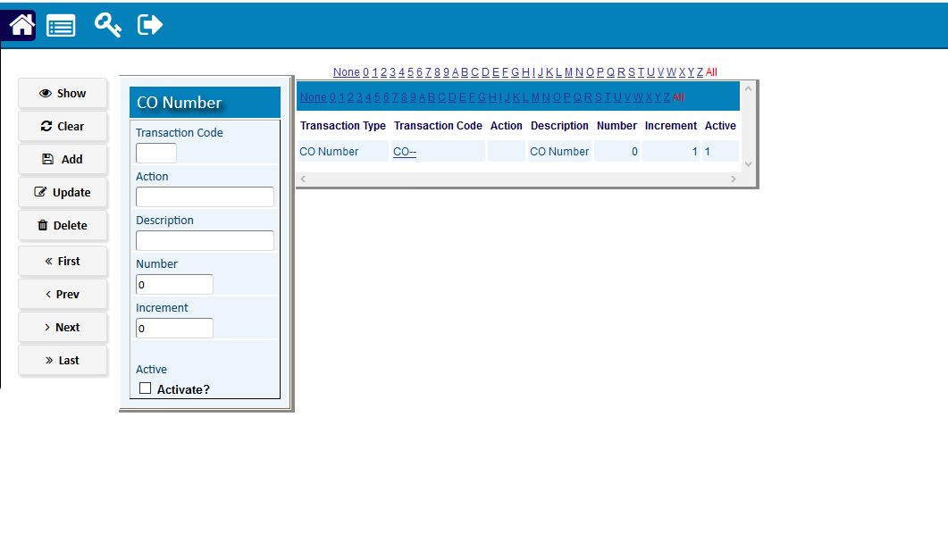

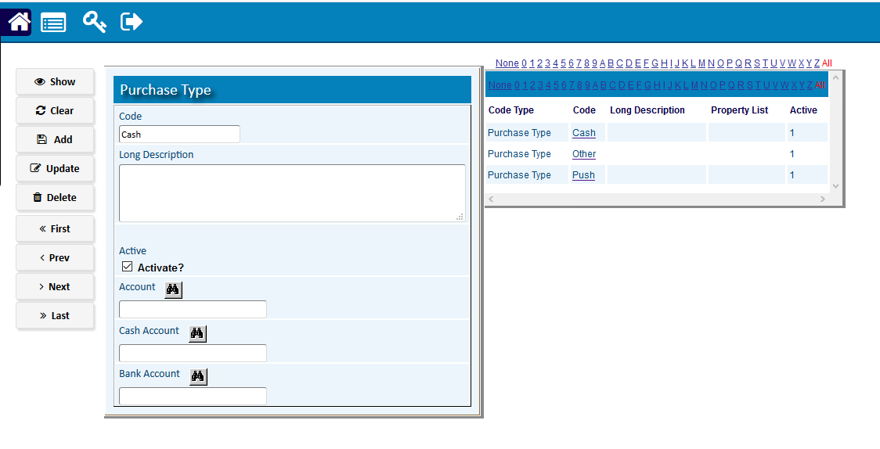

# Party Master

* 1. [**Customers Entry**](http://192.168.1.17:8080/zab/login?screen=cacus&option=Customers+Entry&menuname=bothparty)

|  |  |  |  |
| --- | --- | --- | --- |
| **Step 1** |  |  | Open System **>** Administration **>** Master Setup > Party Master |
| **Step 2** |  |  | Write Customer Name, address, Phone etc. |
| **Step 3** |  |  | Select Customer Group & check the Activate box. |
| **Step 4** |  |  | Click **Add**. |
| **Result** |  |  | A new customer will be Added. |

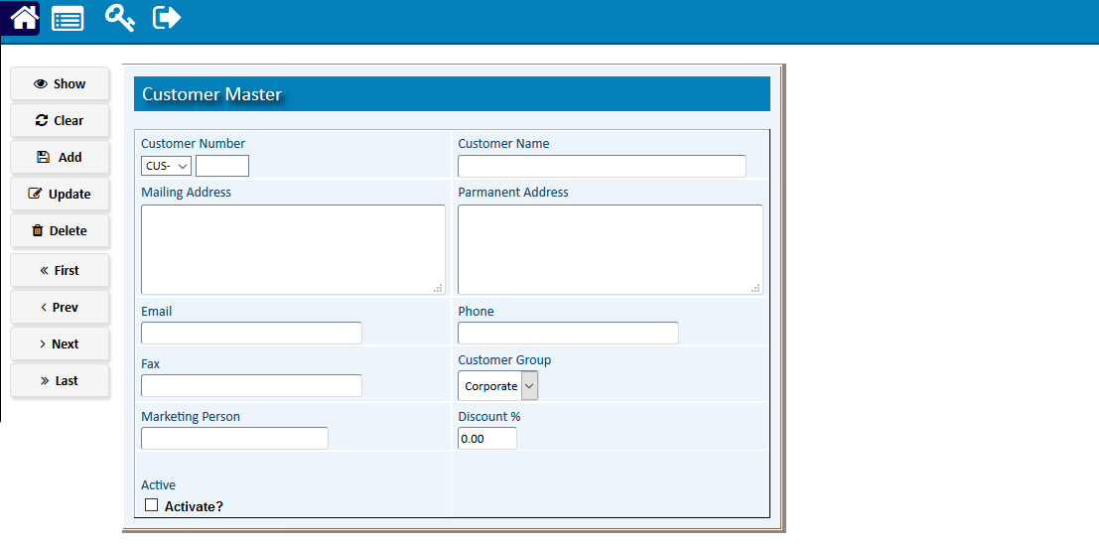

* 1. [**Customer Group**](http://192.168.1.17:8080/zab/login?screen=xcodesgcus&option=Customer+Group&menuname=bothparty)

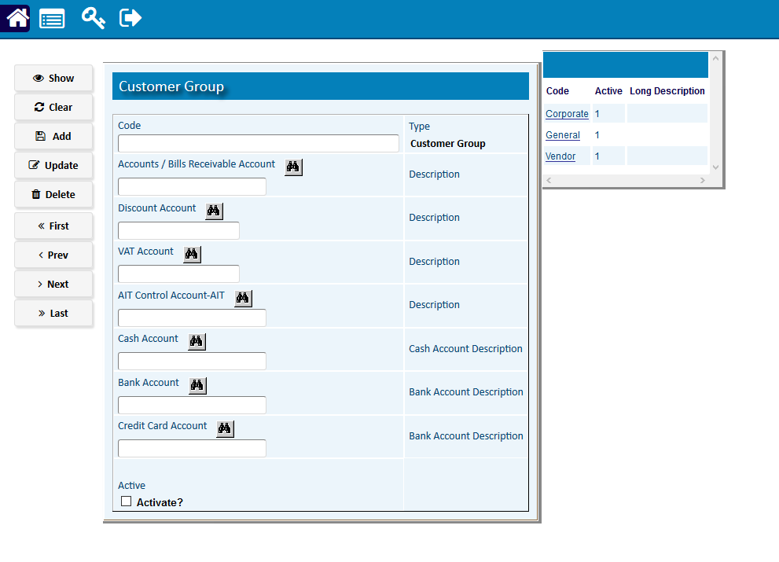

* 1. [**Customer Code**](http://192.168.1.17:8080/zab/login?screen=xtrn%28xtypetrn%3DCustomer+Code%29&option=Customer+Code&menuname=bothparty)

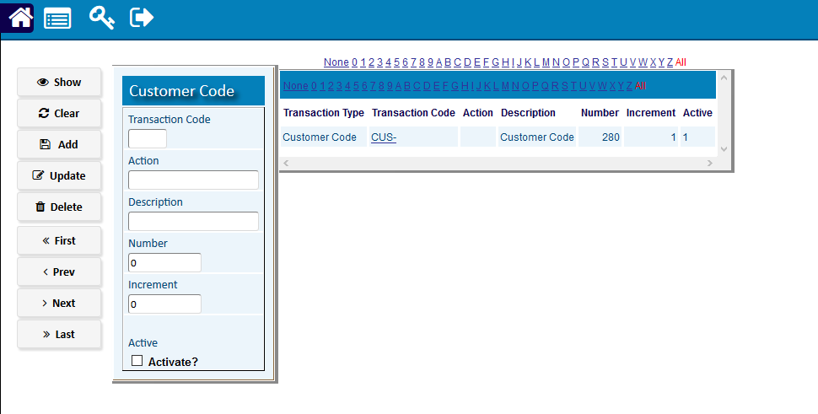

* 1. [**Suppliers Entry**](http://192.168.1.17:8080/zab/login?screen=casup&option=Suppliers+Entry&menuname=bothparty)

|  |  |  |  |
| --- | --- | --- | --- |
| **Step 1** |  |  | Open System **>** Administration **>** Master Setup > Party Master> Supplier Entry |
| **Step 2** |  |  | Write Supplier Name, address, Phone etc. |
| **Step 3** |  |  | Select Supplier Group & check the Activate box. |
| **Step 4** |  |  | Click **Add**. |
| **Result** |  |  | A new Supplier will be Added. |

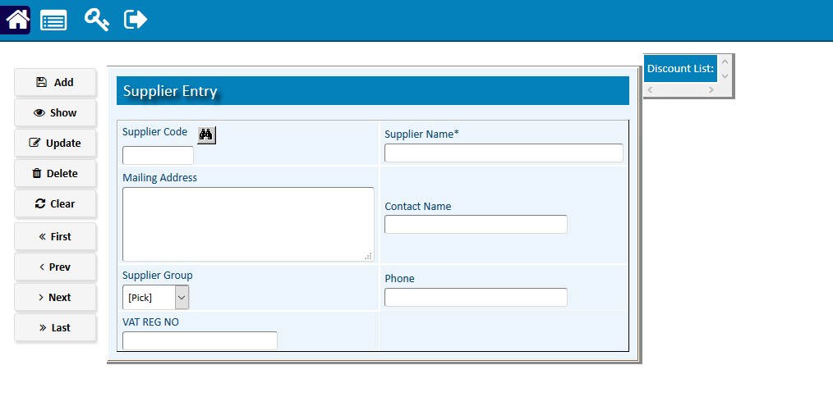

* 1. [**Supplier Groups**](http://192.168.1.17:8080/zab/login?screen=xcodesgsup&option=Supplier+Groups&menuname=bothparty)

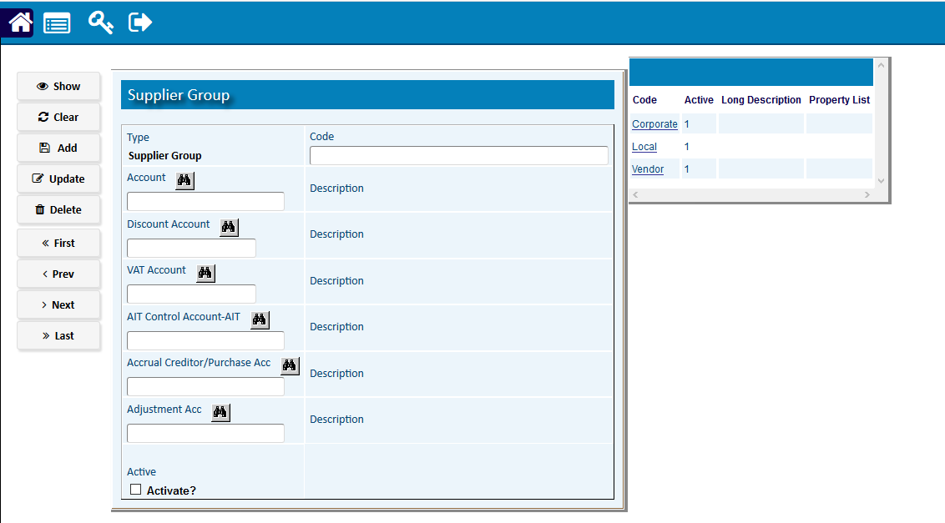

* 1. [**Supplier Code**](http://192.168.1.17:8080/zab/login?screen=xtrn%28xtypetrn%3DSupplier+Code%29&option=Supplier+Code&menuname=bothparty)

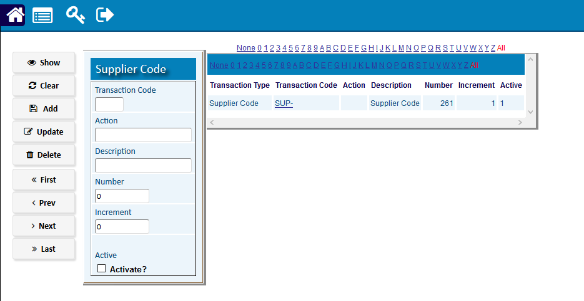

* 1. [**Both Party**](http://192.168.1.17:8080/zab/login?screen=cabothparty&option=Both+Party&menuname=bothparty)

|  |  |  |  |
| --- | --- | --- | --- |
| **Step 1** |  |  | Open System **>** Administration **>** Master Setup > Party Master > Both Party |
| **Step 2** |  |  | Write Customer Name, address, Phone etc. |
| **Step 3** |  |  | Select Customer Group & Supplier Group. |
| **Step 4** |  |  | Click **Add**. |
| **Result** |  |  | A new party of both (customer & supplier) will be Added. |

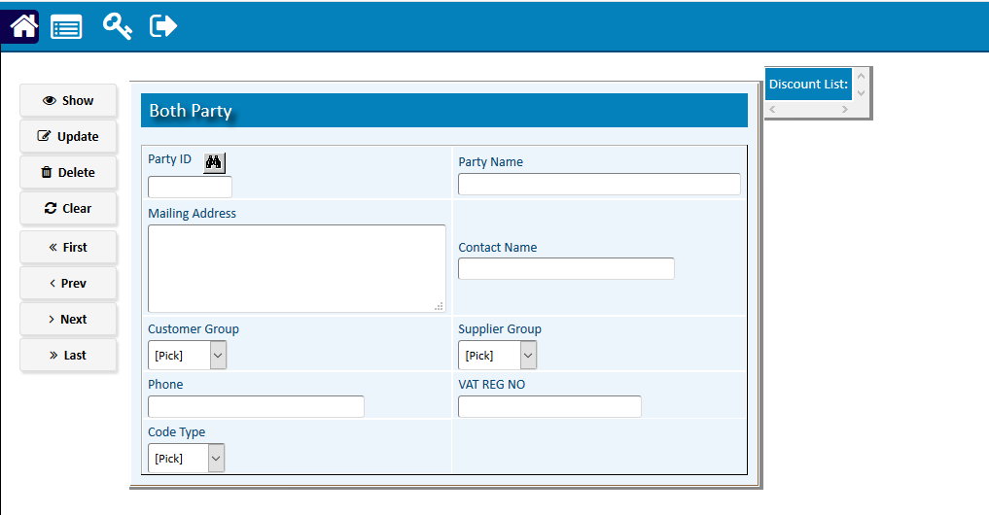

* 1. **Party Migrate**

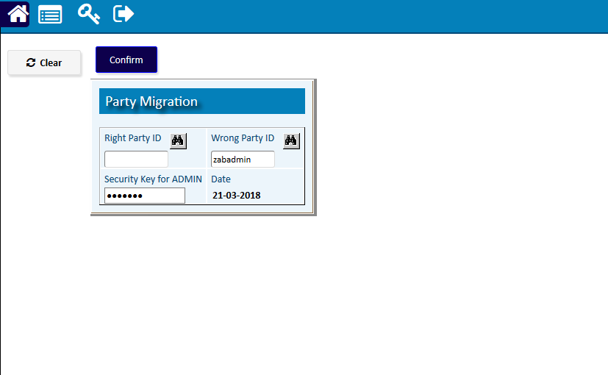

# Item Master

* 1. [**Item**](http://192.168.1.17:8080/zab/login?screen=cacus&option=Customers+Entry&menuname=bothparty) **Master**

|  |  |  |  |
| --- | --- | --- | --- |
| **Step 1** |  |  | Open System **>** Administration **> master Setup** >Item Master > Item Master |
| **Step 2** |  |  | Write Item Name, note, price etc. |
| **Step 3** |  |  | Select Serial Type, Item group, category, unit etc. & check the Activate box. |
|  |  |  |  |
| **Step 4** |  |  | Click **Add**. |
| **Result** |  |  | A new Item will be Added. |

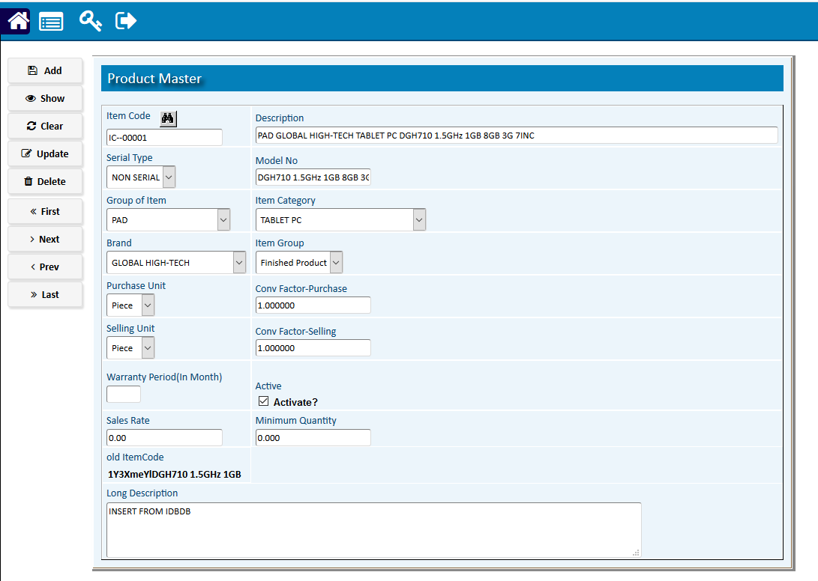

* 1. [**Brand**](http://192.168.1.17:8080/zab/login?screen=xcodesgcus&option=Customer+Group&menuname=bothparty)

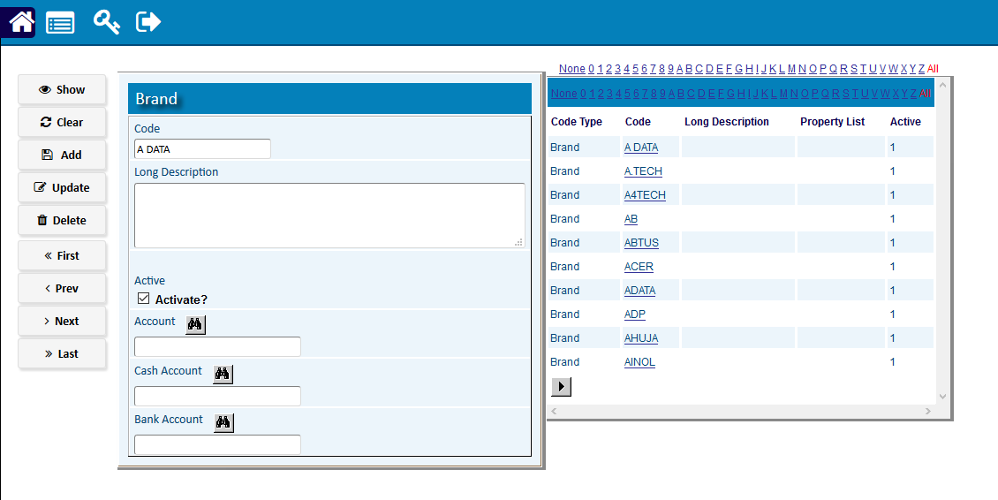

* 1. [**Item**](http://192.168.1.17:8080/zab/login?screen=xtrn%28xtypetrn%3DCustomer+Code%29&option=Customer+Code&menuname=bothparty) **Type**

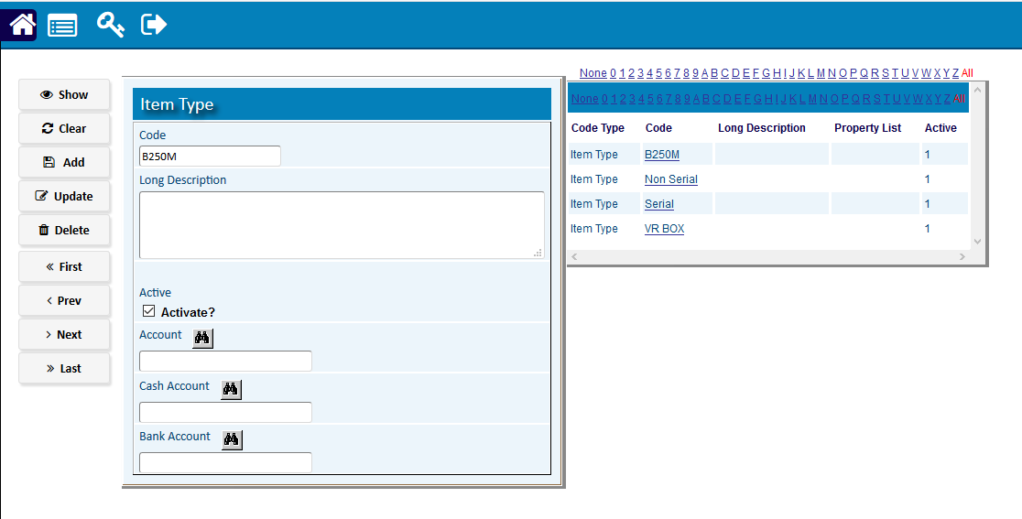

* 1. [**Group**](http://192.168.1.17:8080/zab/login?screen=casup&option=Suppliers+Entry&menuname=bothparty) **Of Item**

|  |  |  |  |
| --- | --- | --- | --- |
| **Step 1** |  |  | Open System **>** Administration **>** Master Setup > Party Master> Supplier Entry |
| **Step 2** |  |  | Write Supplier Name, address, Phone etc. |
| **Step 3** |  |  | Select Supplier Group & check the Activate box. |
| **Step 4** |  |  | Click **Add**. |
| **Result** |  |  | A new Supplier will be Added. |

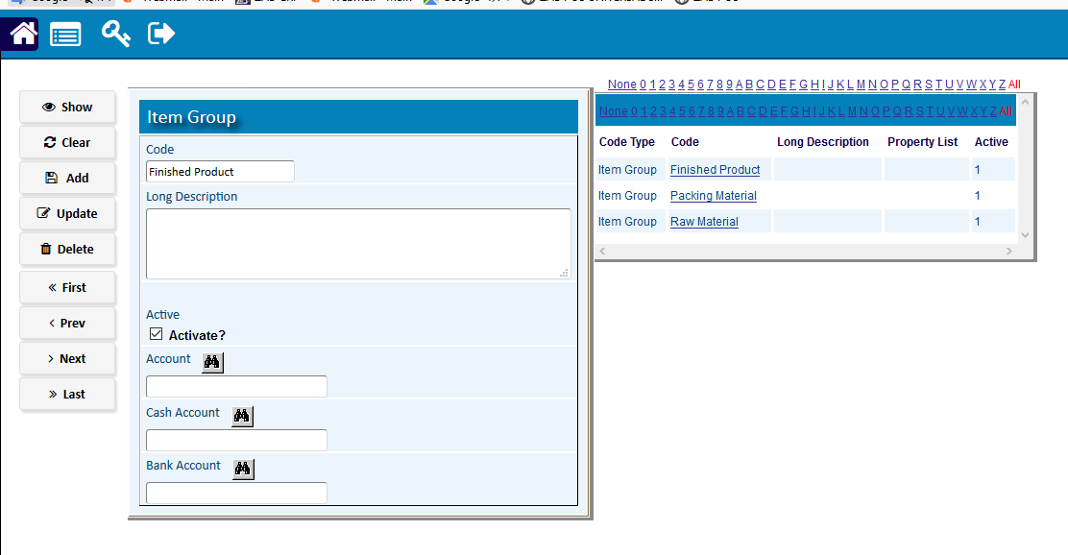

* 1. **Item Category**

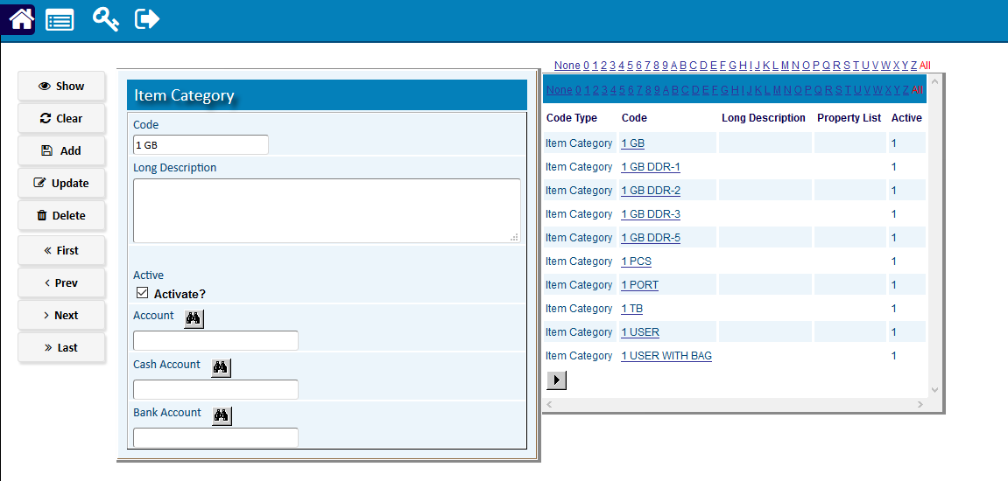

* 1. [**Item**](http://192.168.1.17:8080/zab/login?screen=xtrn%28xtypetrn%3DSupplier+Code%29&option=Supplier+Code&menuname=bothparty) **Class**

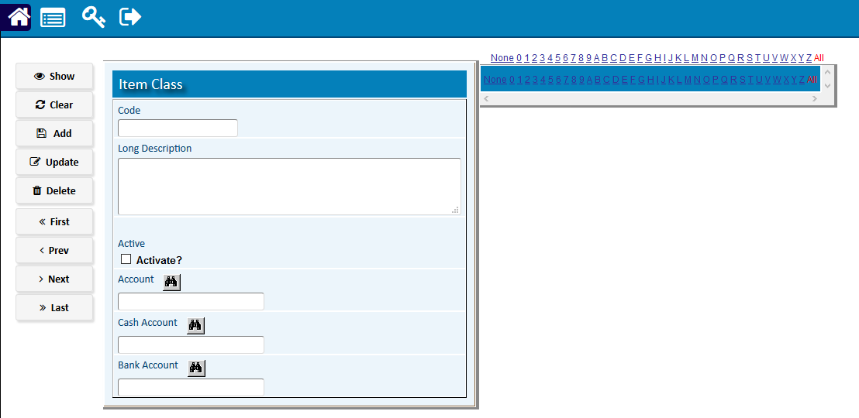

* 1. **Purchase Type**

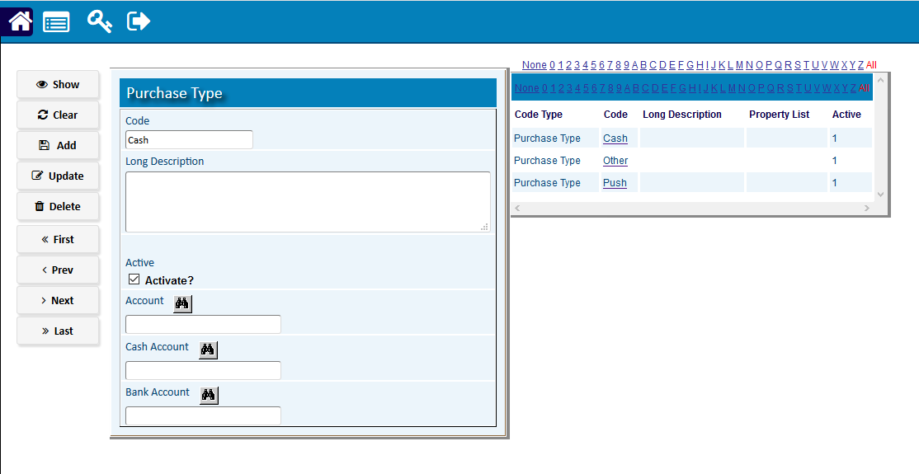

* 1. **Item Code**

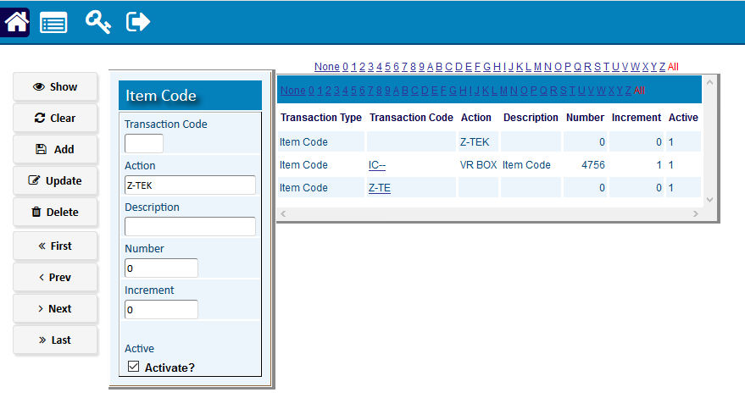

* 1. **Item Group**



* 1. **Store Master**

|  |  |  |  |
| --- | --- | --- | --- |
| **Step 1** |  |  | Open System **>** Administration **> master Setup** >Item Master > Store Master |
| **Step 2** |  |  | Write Store Desc. |
| **Step 3** |  |  | Select Store Type & check the Activate box. |
|  |  |  |  |
| **Step 4** |  |  | Click **Add**. |
| **Result** |  |  | A new Store will be Added. |

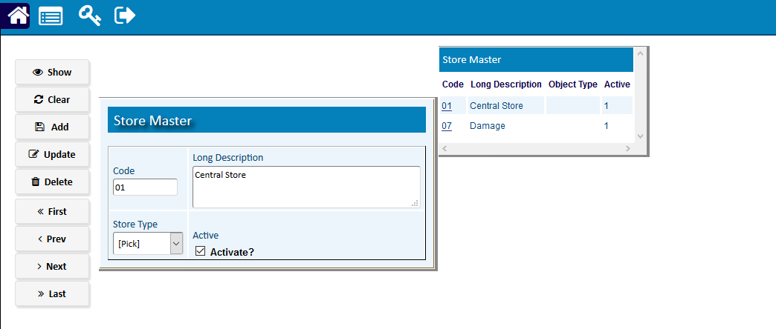

* 1. **Branch master**

|  |  |  |  |
| --- | --- | --- | --- |
| **Step 1** |  |  | Open System **>** Administration **> master Setup** > **Branch** Master |
| **Step 2** |  |  | Write **Branch** Name, address, phone etc. |
| **Step 3** |  |  | check the Activate box. |
|  |  |  |  |
| **Step 4** |  |  | Click **Add**. |
| **Result** |  |  | A new **Branch** will be Added. |

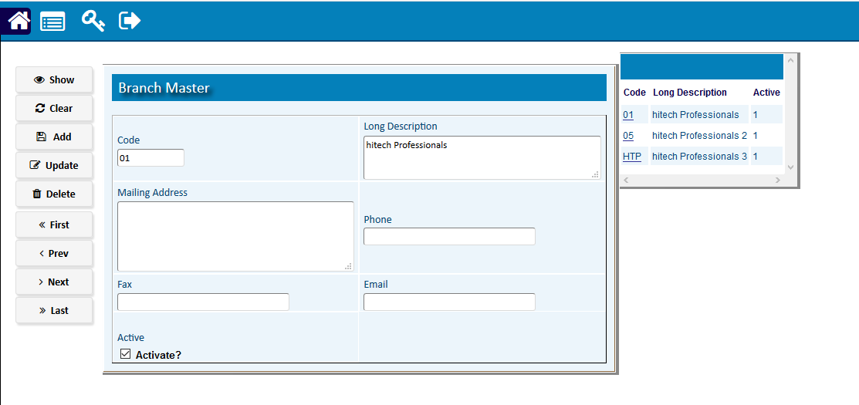

* 1. **Serial Code**

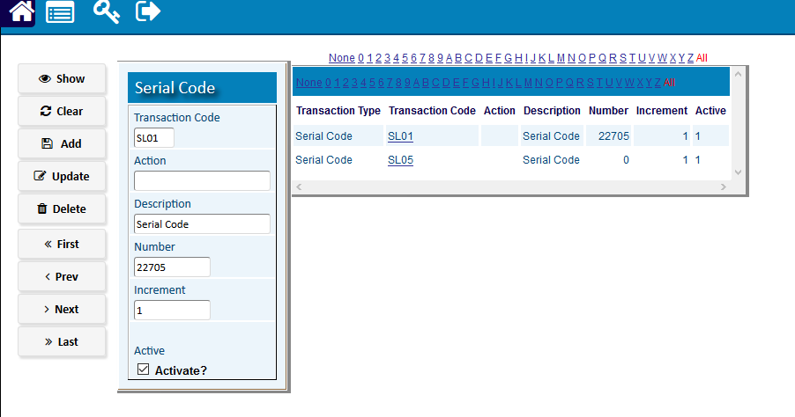

* 1. **Non Serial Code**

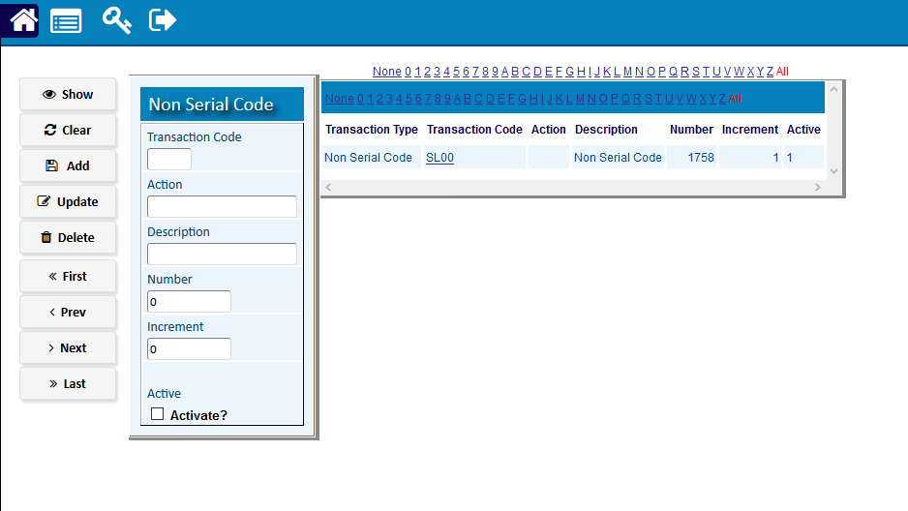

* 1. **Bank**

|  |  |  |  |
| --- | --- | --- | --- |
| **Step 1** |  |  | Open System **>** Administration **> master Setup** > **Bank** |
| **Step 2** |  |  | Write Bank name, **Branch** Name, address, phone etc. |
| **Step 3** |  |  | Insert the account number. |
|  |  |  |  |
| **Step 4** |  |  | Click **Add**. |
| **Result** |  |  | A new **Bank acc.** will be Added. |

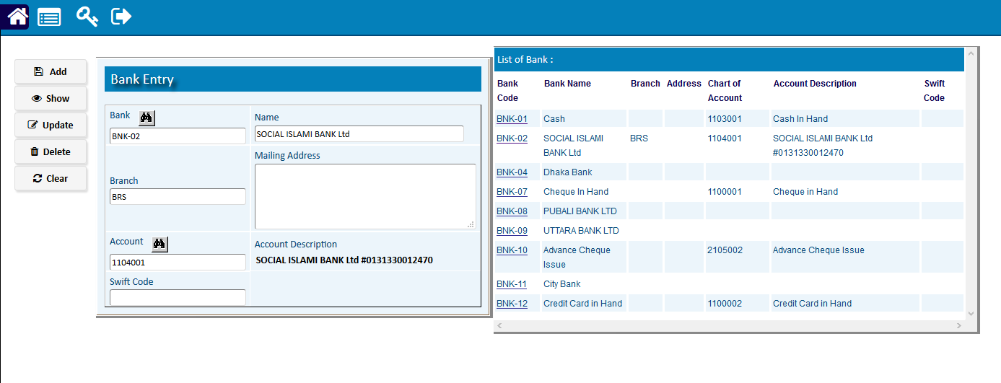

* 1. **Year**

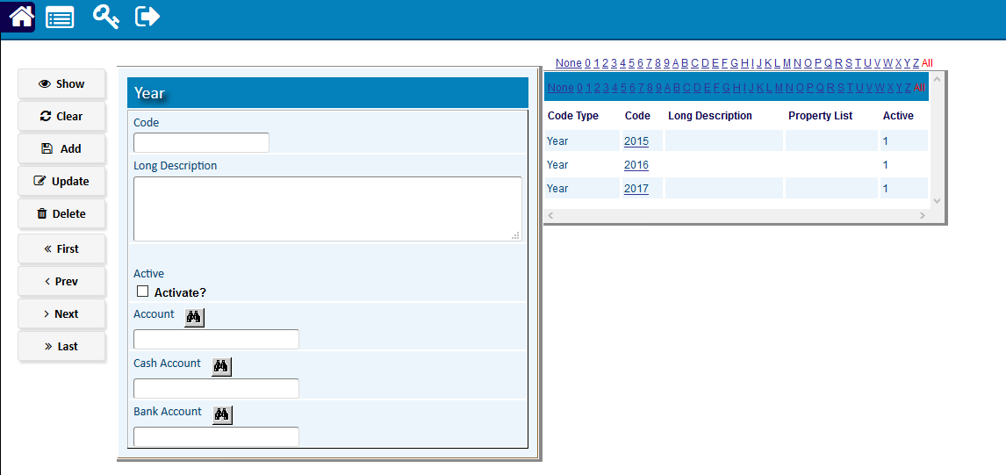

# System Administration

* 1. [Users](javascript:run1()&menuname=users)
     1. [Manage Users](http://192.168.1.17:8080/zab/login?screen=xusers&option=Manage+Users&menuname=users)

|  |  |  |  |
| --- | --- | --- | --- |
| **Step 1** |  |  | Open System **> System** Administration **> users > manage users** |
| **Step 2** |  |  | Write user id & password. |
| **Step 3** |  |  | Define Role, Access Code & Store. |
| **Step 4** |  |  | check the Activate box. |
| **Step 5** |  |  | Click **Add**. |
| **Result** |  |  | A new **User** will be Added. |

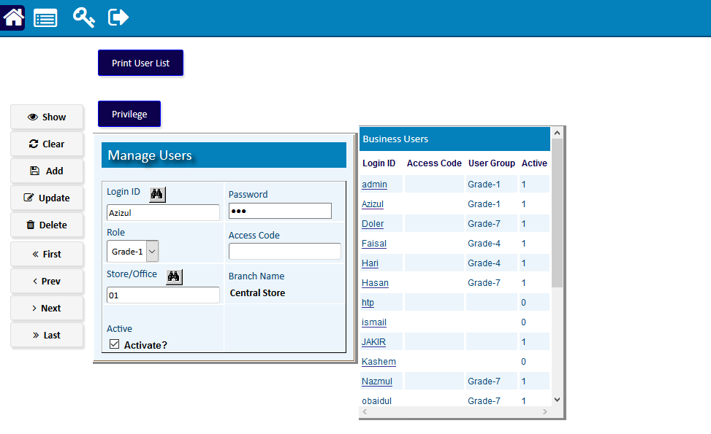

* + 1. [User Permits Entry](http://192.168.1.17:8080/zab/login?screen=xpermits&option=User+Permits+Entry&menuname=users)

|  |  |  |  |
| --- | --- | --- | --- |
| **Step 1** |  |  | Open System **> System** Administration **> Users > User Permit Entry.** |
| **Step 2** |  |  | Select the Main Menu, Option, Child Option & Module Name. |
| **Step 3** |  |  | Define Access List. |
| **Step 4** |  |  | Check the Activate Box. |
| **Step 5** |  |  | Click **Add**. |
| **Step 6** |  |  | Repeat Step 2 To 5 To Add Multi |
| **Result** |  |  | A New **User Permit Entry** Will Be Added. |

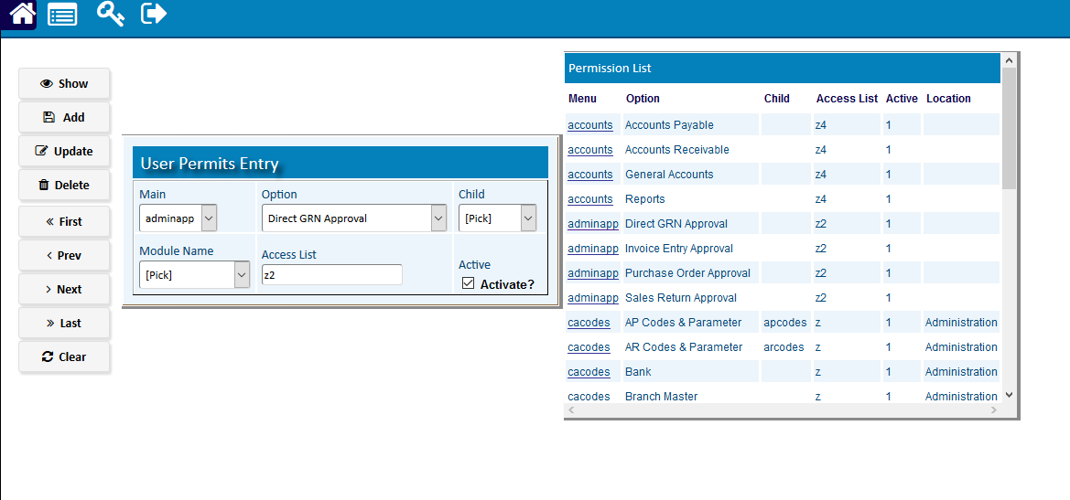

* + 1. [Define Role Name](http://192.168.1.17:8080/zab/login?screen=xrolesdef&option=Define+Role+Name&menuname=users)

|  |  |  |  |
| --- | --- | --- | --- |
| **Step 1** |  |  | Open System **> System** Administration **> users > Define Role Name** |
| **Step 2** |  |  | Write Role Name. |
| **Step 3** |  |  | check the Activate box. |
| **Step 4** |  |  | Click **Add**. |
| **Result** |  |  | A new **Role** will be Added. |

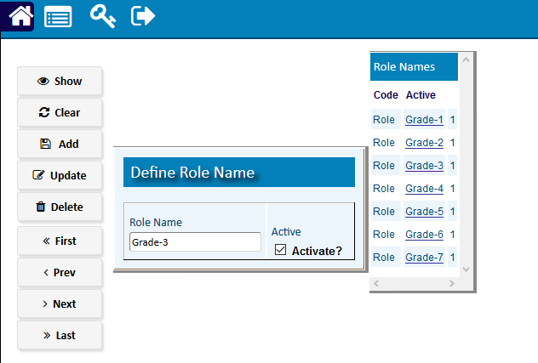

* + 1. [Manage Roles](http://192.168.1.17:8080/zab/login?screen=xrolesman&option=Manage+Roles&menuname=users)

|  |  |  |  |
| --- | --- | --- | --- |
| **Step 1** |  |  | Open System **> System** Administration **> users > manage roles** |
| **Step 2** |  |  | Define Role Name, Access Code. |
| **Step 3** |  |  | check the Activate box. |
| **Step 4** |  |  | Click **Add**. |
| **Result** |  |  | A new **User Role** will be Managed. |

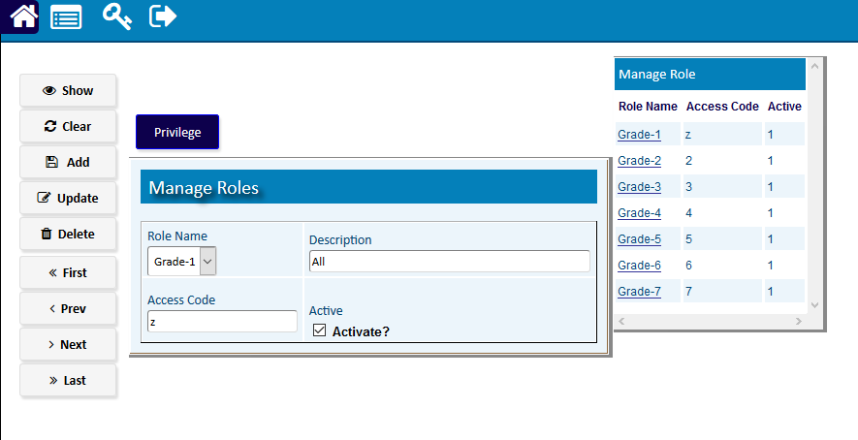

* + 1. [Module Entry](http://192.168.1.17:8080/zab/login?screen=xcodes%28xtype%3DModule%29&option=Module+Entry&menuname=users)

|  |  |  |  |
| --- | --- | --- | --- |
| **Step 1** |  |  | Open System **> System** Administration **> Users > Module Entry.** |
| **Step 2** |  |  | Write Code. |
| **Step 3** |  |  | Check the Activate Box. |
| **Step 4** |  |  | Click **Add**. |
| **Result** |  |  | A New **Module** Will Be Added. |

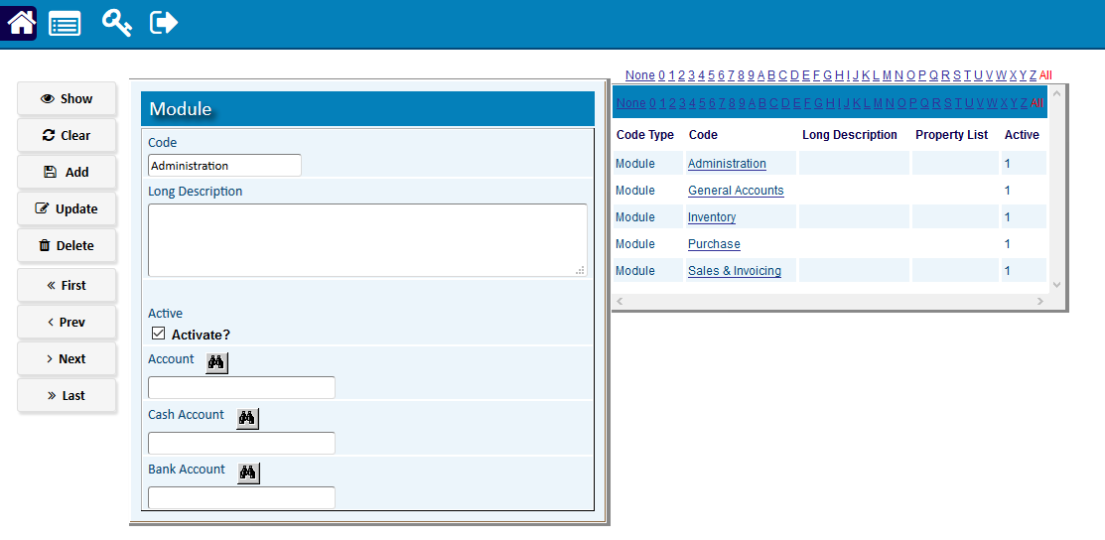

* + 1. [Menu Code Entry](http://192.168.1.17:8080/zab/login?screen=xcodes%28xtype%3DMenu%29&option=Menu+Code+Entry&menuname=users)

|  |  |  |  |
| --- | --- | --- | --- |
| **Step 1** |  |  | Open System **> System** Administration **> Users > Menu Code Entry.** |
| **Step 2** |  |  | Write Code. |
| **Step 3** |  |  | Check the Activate Box. |
| **Step 4** |  |  | Click **Add**. |
| **Result** |  |  | A New **Menu** Will Be Added. |

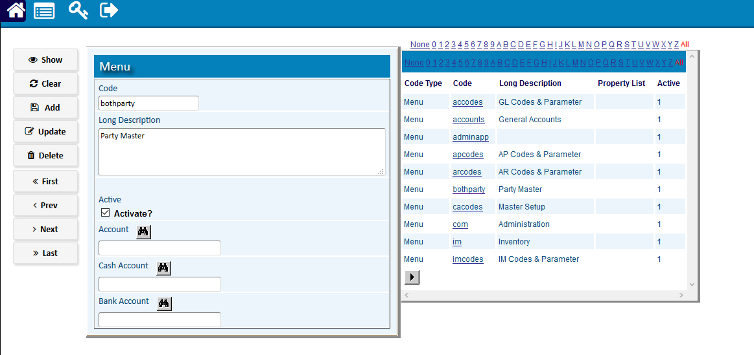

* + 1. [Option Entry](http://192.168.1.17:8080/zab/login?screen=xcodes%28xtype%3DOption%29&option=Option+Entry&menuname=users)

|  |  |  |  |
| --- | --- | --- | --- |
| **Step 1** |  |  | Open System **> System** Administration **> Users > Option Entry.** |
| **Step 2** |  |  | Write Code. |
| **Step 3** |  |  | Check the Activate Box. |
| **Step 4** |  |  | Click **Add**. |
| **Result** |  |  | A New **Option** Will Be Added. |

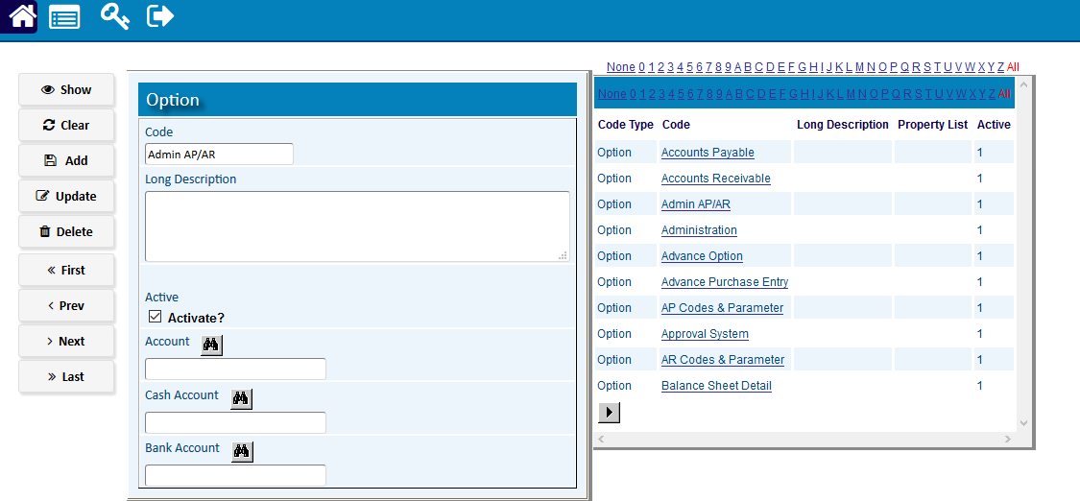

* + 1. [Screen Entry](http://192.168.1.17:8080/zab/login?screen=zscreenheader&option=Screen+Entry&menuname=users)

|  |  |  |  |
| --- | --- | --- | --- |
| **Step 1** |  |  | Open System **> System** Administration **> Users > Screen Entry.** |
| **Step 2** |  |  | Write Code. |
| **Step 3** |  |  | Check the Activate Box. |
| **Step 4** |  |  | Click **Add**. |
| **Result** |  |  | A New **Screen** Will Be Added. |

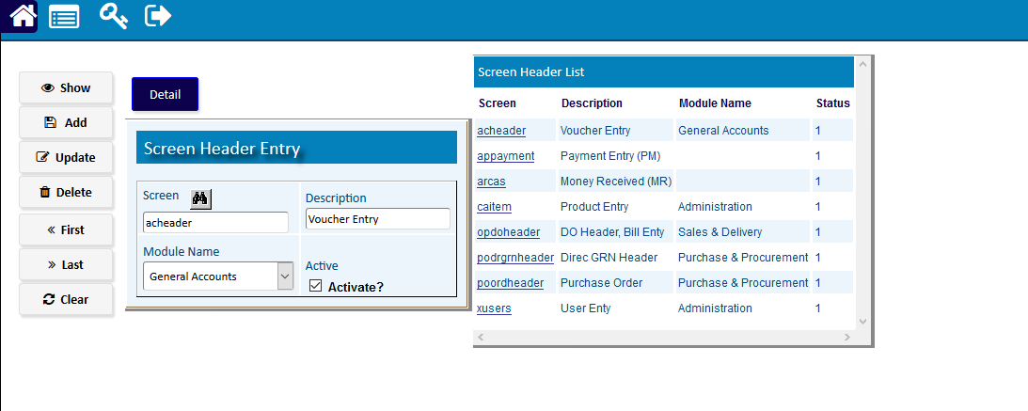

* 1. [Logs](javascript:run1()&menuname=logs)
     1. [Error Logs](http://192.168.1.17:8080/zab/login?screen=zlogs&option=Error+Logs&menuname=logs)

|  |  |  |  |
| --- | --- | --- | --- |
| **Step 1** |  |  | Open System **> System** Administration **> Logs > Error Logs** |
| **Step 2** |  |  | Write user id & password. |
| **Step 3** |  |  | Click **First** to show the Last Error. |
| **Result** |  |  | The last error created by user will be shown in detail. |

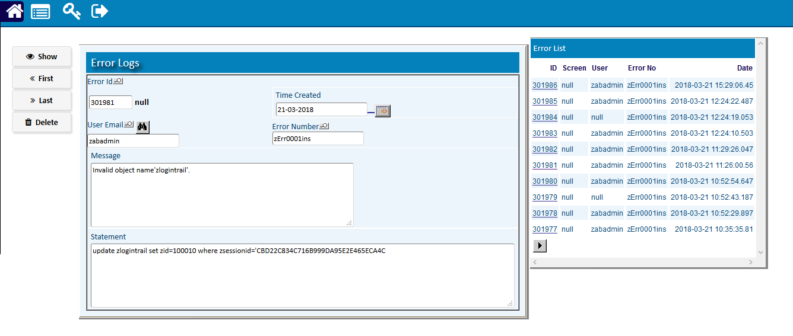

* 1. [Company Profile](http://192.168.1.17:8080/zab/login?screen=zbusiness&option=Company+Profile&menuname=Setup)

|  |  |  |  |
| --- | --- | --- | --- |
| **Step 1** |  |  | Open System **> System** Administration **> Company Profile.** |
| **Step 2** |  |  | Write Your Company details. |
| **Step 3** |  |  | Define Role, Access Code & Store. |
| **Step 4** |  |  | Click **Update**. |
| **Result** |  |  | Your Company Profilewill be Updated. |

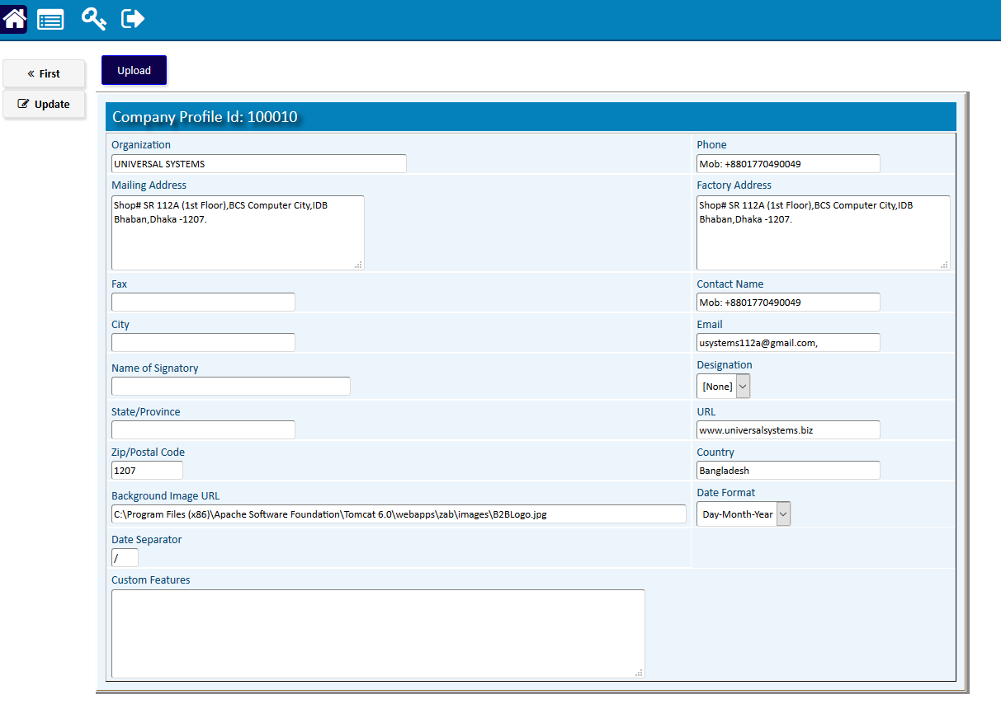

# Advance Option

# Serial History

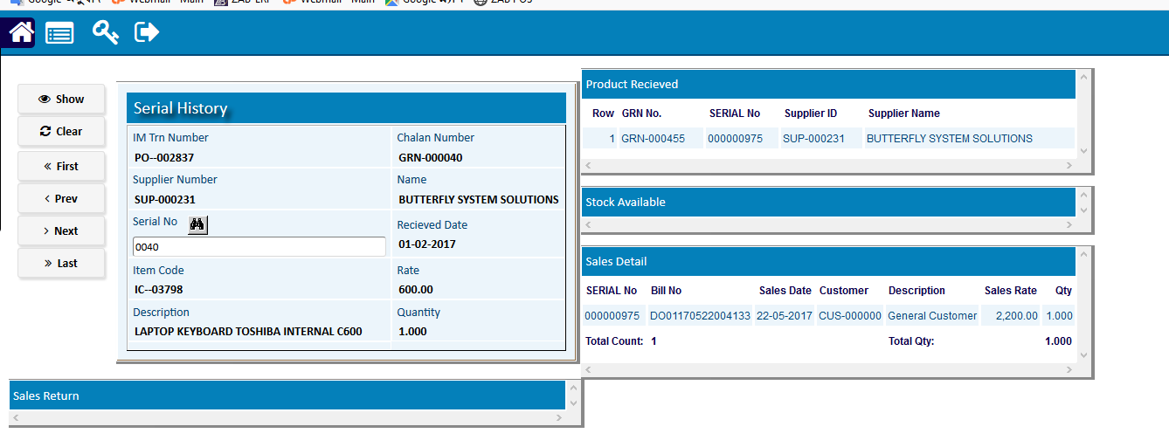

# Supplier Update (RE)

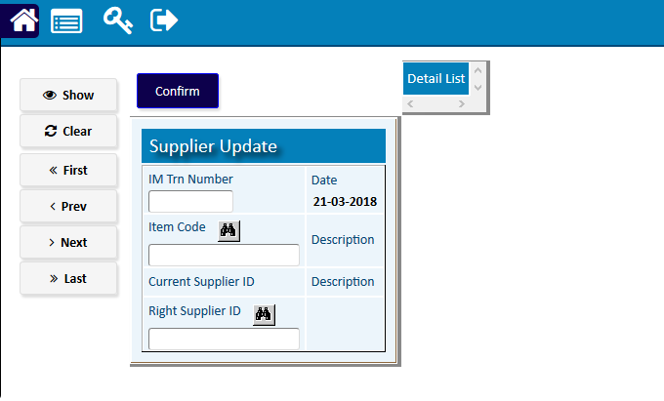

# Party Migrate

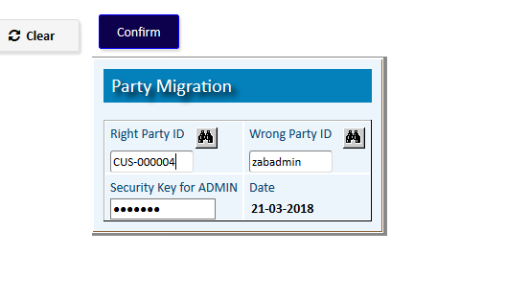

# Admin AP/AR

* 1. [Supplier Adjustment (Update)](http://192.168.1.17:8080/zab/login?screen=appaymentadjup&option=Supplier+Adjustment+%28Update%29&menuname=adminapar)

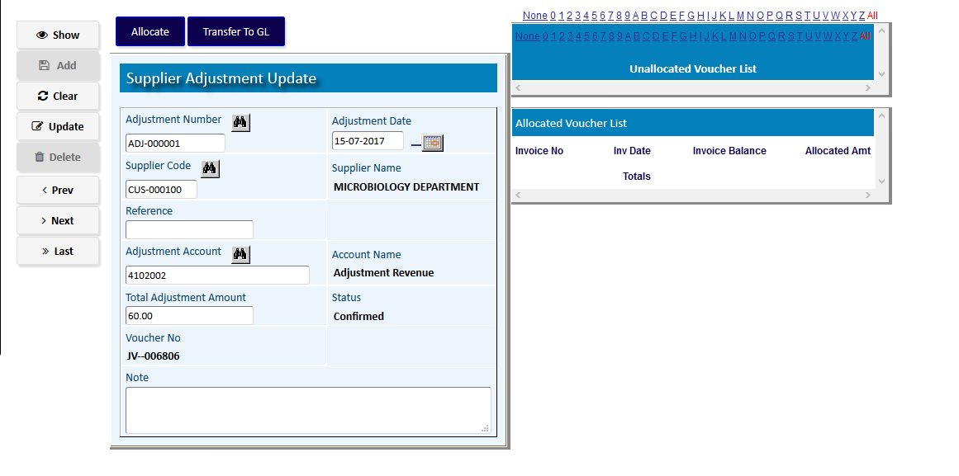

* 1. [Admin -> AP](javascript:run1()&menuname=adminap)
     1. Payment (Cash)

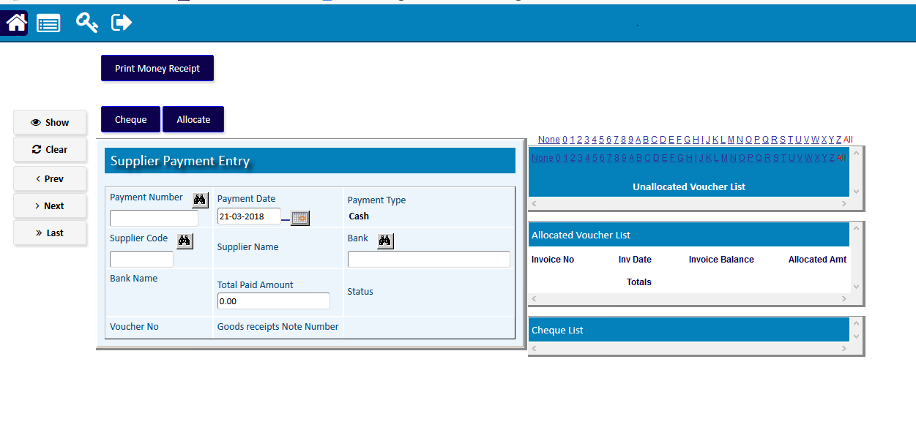

* + 1. Transfer To AP (Update)

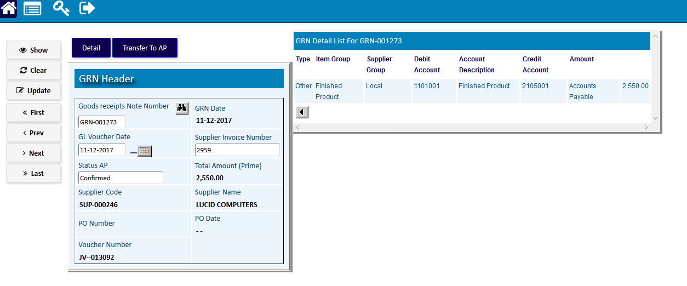

* + 1. Supplier Invoice

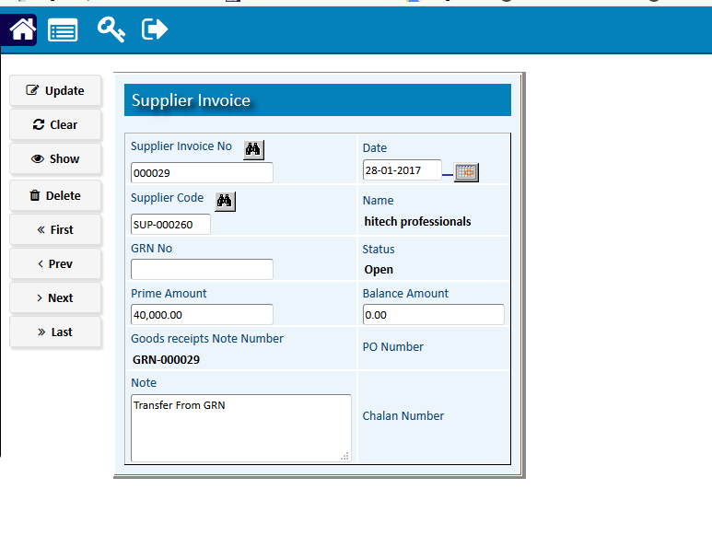

* + 1. Transfer To JV (Update)

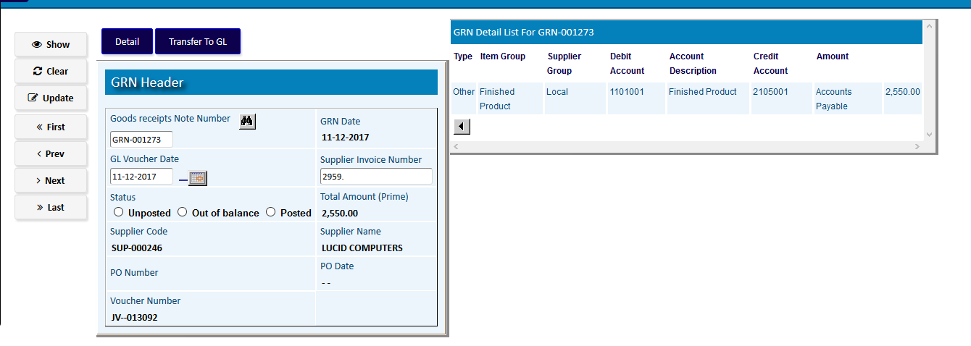

* 1. [Admin -> AR](javascript:run1()&menuname=adminar)
     1. [Transfer To AP (Update)](http://192.168.1.17:8080/zab/login?screen=pogrnheaderacadmin&option=Transfer+To+AP+%28Update%29&menuname=adminar)
     2. [Customer Invoice](http://192.168.1.17:8080/zab/login?screen=arhedadmin&option=Customer+Invoice&menuname=adminar)
     3. [Transfer To JV (Update)](http://192.168.1.17:8080/zab/login?screen=pogrnheaderacadminjv&option=Transfer+To+JV+%28Update%29&menuname=adminar)

# Error Handling

* 1. [Sales (Update)](http://192.168.1.17:8080/zab/login?screen=opdoheaderedit&option=Sales+%28Update%29&menuname=admintool)

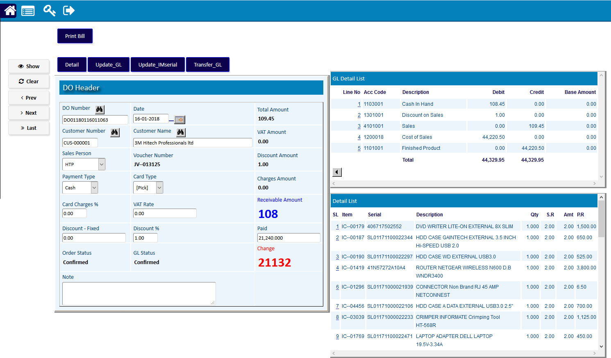

* 1. [GRN (Update)](http://192.168.1.17:8080/zab/login?screen=podrgrnheaderedit&option=GRN+%28Update%29&menuname=admintool)

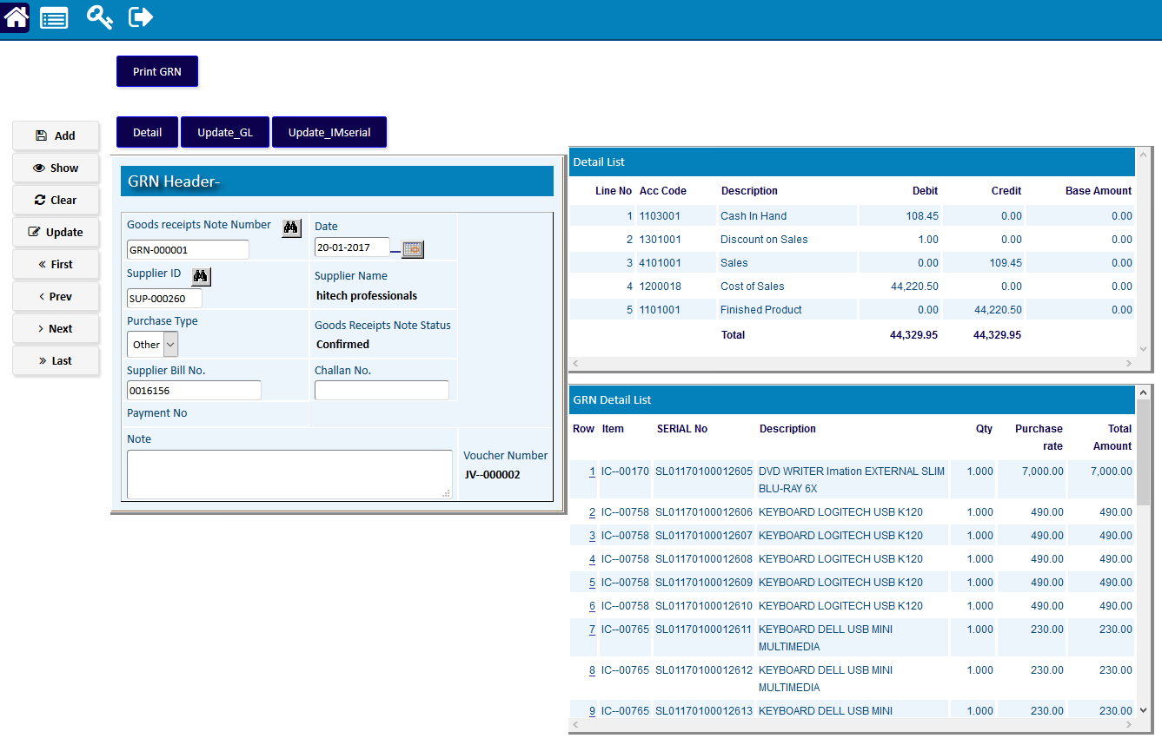

* 1. [DO Relative Delete](http://192.168.1.17:8080/zab/login?screen=opdoreldelete&option=DO+Relative+Delete&menuname=admintool)

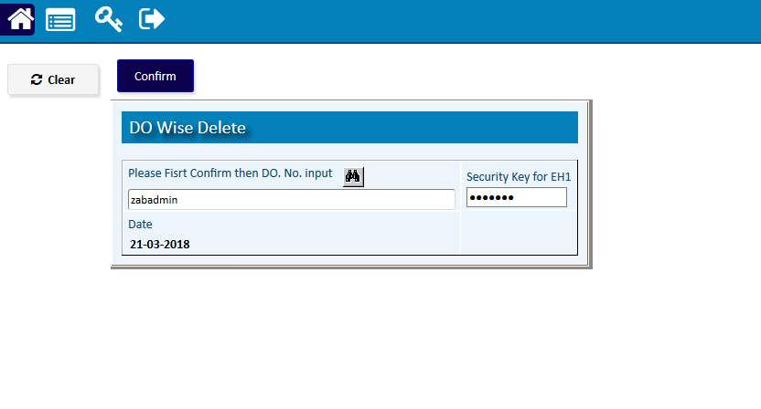

* 1. [Admin -> EH Over Qty](javascript:run1()&menuname=adminehoverqty)
     1. [EH-1 SOLD Qty](http://192.168.1.17:8080/zab/login?screen=adminehsoldrqty&option=EH-1+SOLD+Qty&menuname=adminehoverqty)
     2. [EH-2 Over Qty](http://192.168.1.17:8080/zab/login?screen=adminehoverqty&option=EH-2+Over+Qty&menuname=adminehoverqty)
     3. [EH-3 Bal Qty](http://192.168.1.17:8080/zab/login?screen=adminehbal&option=EH-3+Bal+Qty&menuname=adminehoverqty)

# SQLDB Backup

|  |  |  |
| --- | --- | --- |
| **Step 1** |  | Open System **>** Administration> SQLDB Backup |
| **Step 2** |  | Write Store path (Check the existence of specified Drive & Folder ) & Insert Security key. |
| **Step 3** |  | Click **Confirm** |
| **Result** |  | Database Backup will be stored to local PC |

